**BAHRIA UNIVERSITY KARACHI CAMPUS**

**DEPARTMENT OF SOFTWARE ENGINEERING**



**TOPIC NAME: SIMPLIX**

**COURSE NAME: WEB ENGINEERING LAB**

**COURSE CODE:**

**NAMES** **REGISTRATION NO**

* **Ilsa Asif 46107**
* **Aneela Karim 46088**

**INTRODUCTION**

Simplix is a web based website which is designed for the normal users. The purpose of designing this website is to provide entertainment to the users by watching online movies by just going to the simplix. To watch online movies one must have a strong wifi or internet connection. Simplix provides you a platform where users can watch their favorite movie without any struggle to find a specific movie.

Simplix provides different genres of films and the most amazing part is, it also provides **TV SERIES** to watch online without making an account and paying for it on Simplix. This website can be used by any user as it a user friendly website.

Visit the home page of the website, you will find a plethora of tabs. It includes genres, years, movies, and TV series. Users are free to choose the desired genre of the related movie on the website.

**PROBLEMs**

* The problem which led us to design this website is that people find difficulty on watching online movies.
* There are not much websites on internet which provides online movies of different genres and of different years.
* Series are also not found online, as people have to make accounts and pay for it on different applications to watch series.
* Not every movie or latest movies are provided on internet.
* Users have to pay money for watching movies on internet.

**SOLUTION**

The problems stated above make us to design a website which allows users to watch online movies of their favorite ones. People love to watch online movies without paying a single penny so our website doesn’t require a single penny to watch movies. The one who want to watch movies should have a strong wifi connection*.*it is an excellent website that lets users access to stream to watch different genres of films. The best thing is all movies available are free.

Simplix doesn’t ask you to go through its sophisticated and hectic registration process to watch online movies. The users with its easy to use interface can watch all sort of popular movies and TV series with an ease. On the basis of the preference of the genre, you can choose to watch your desired films.

**OUTPUT**

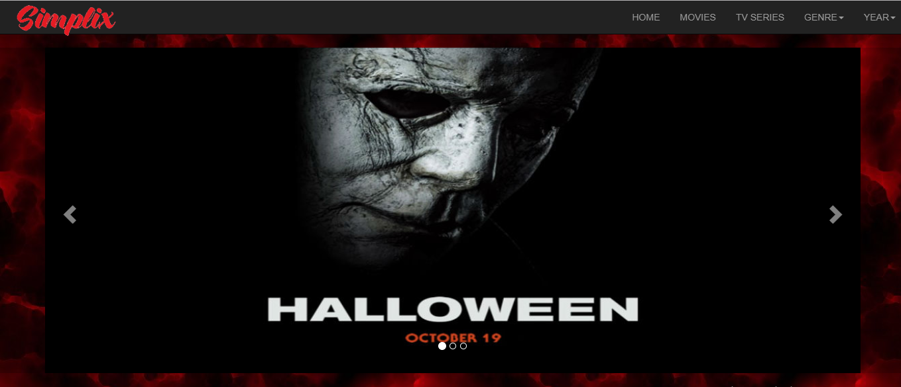**HOME PAGE**

**ALL MOVIES**

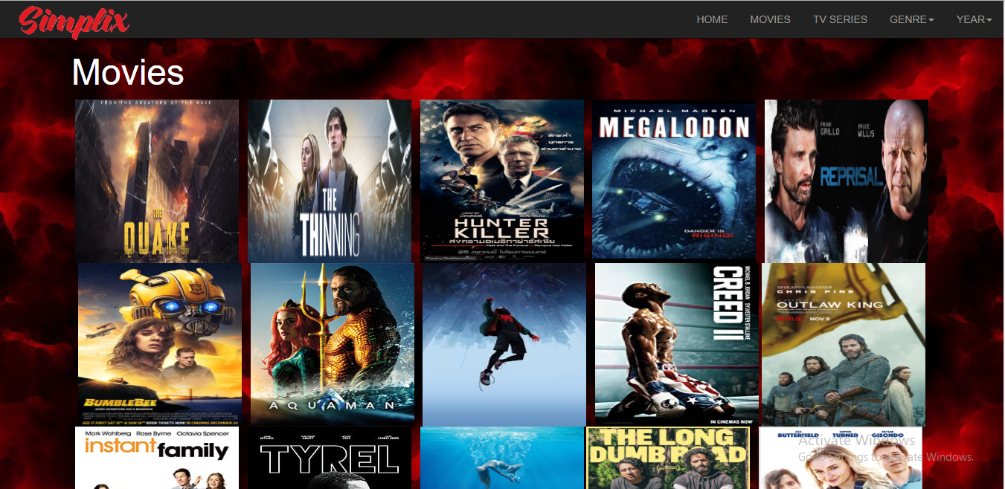

**TV SERIES**

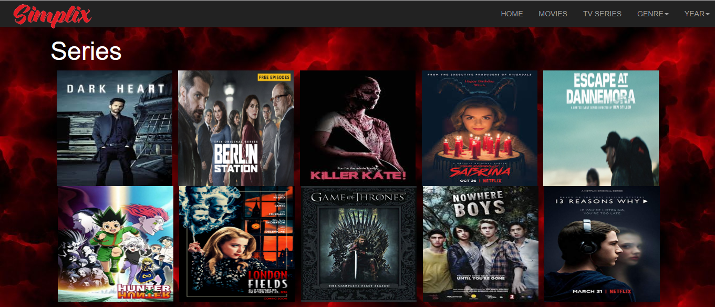

**GENRES**

**ACTION**

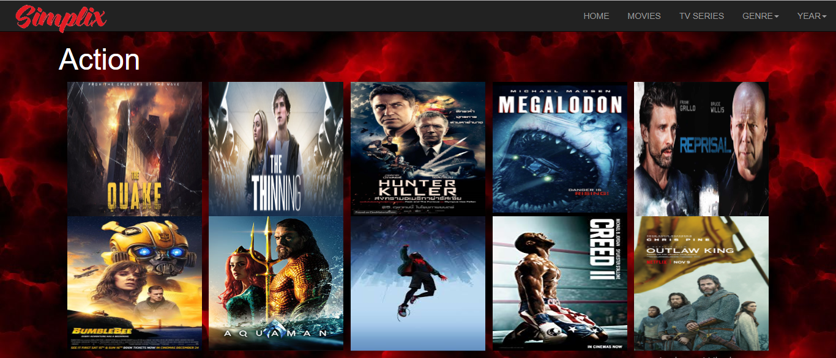

**THRILLER**

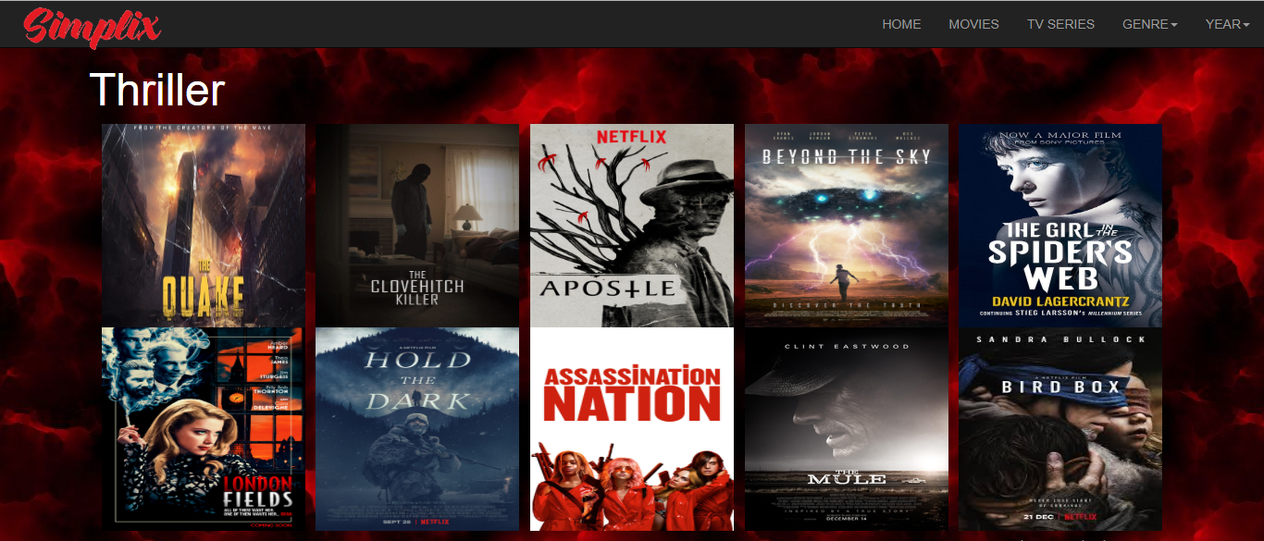

**HORROR**

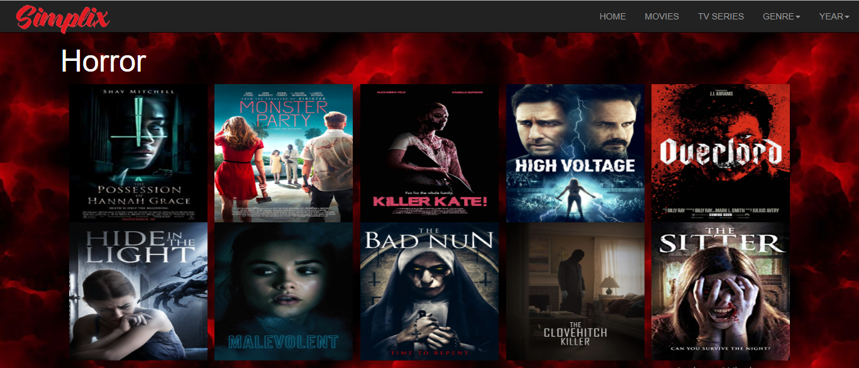

**FANTASY**

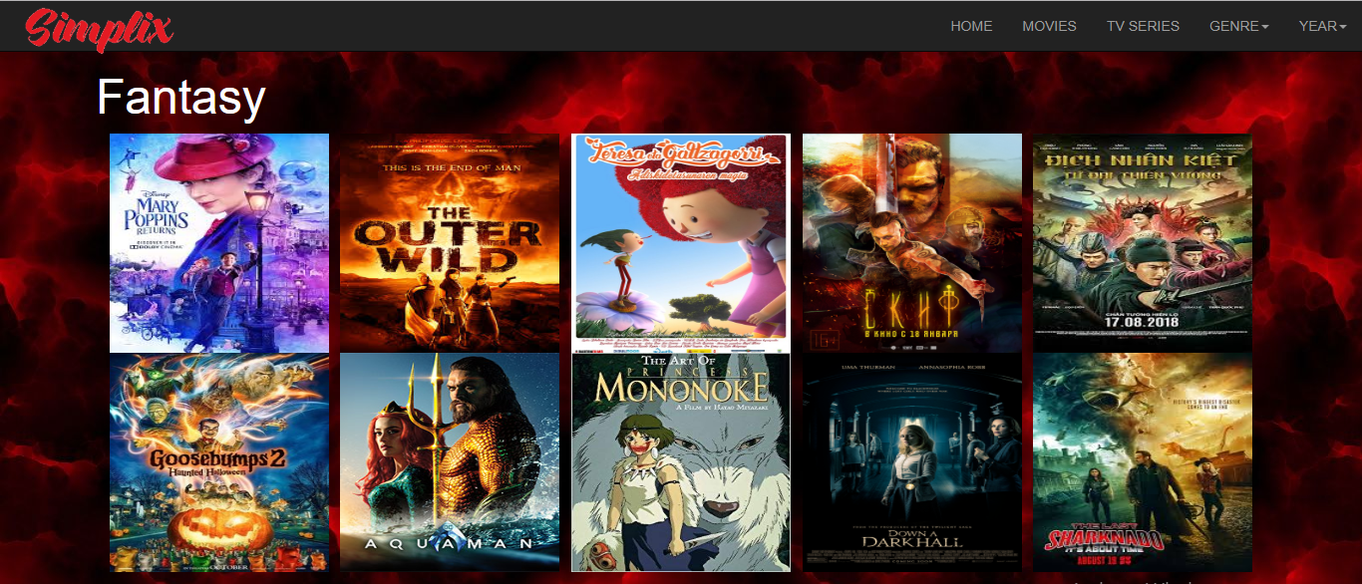

**COMEDY**

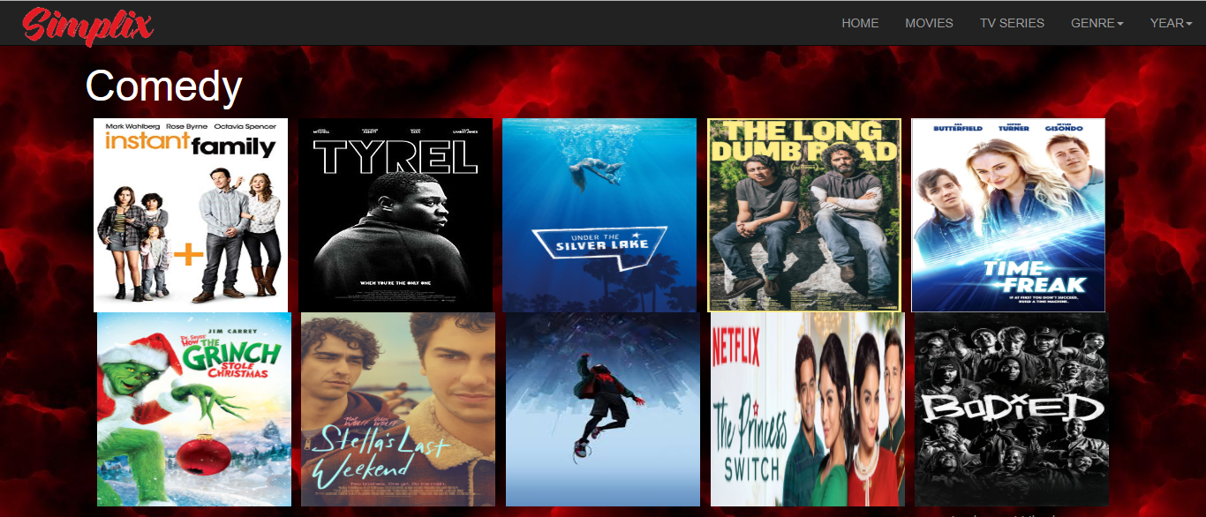

**SCIENCE-FICTION**

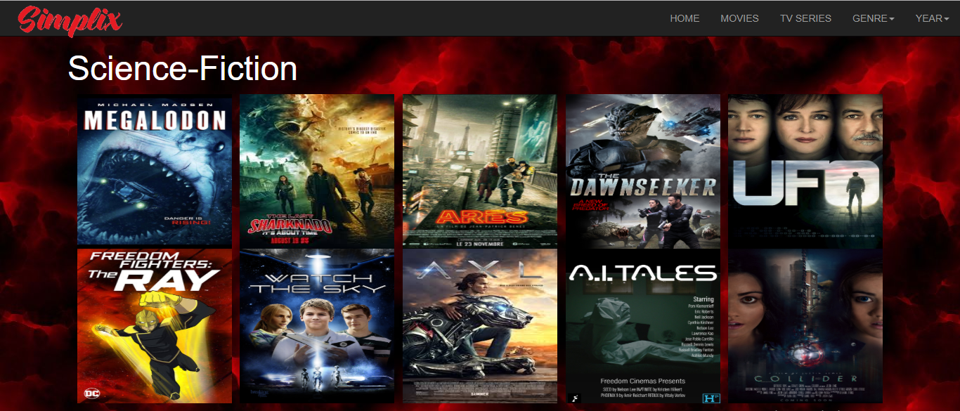

**MYSTERY**

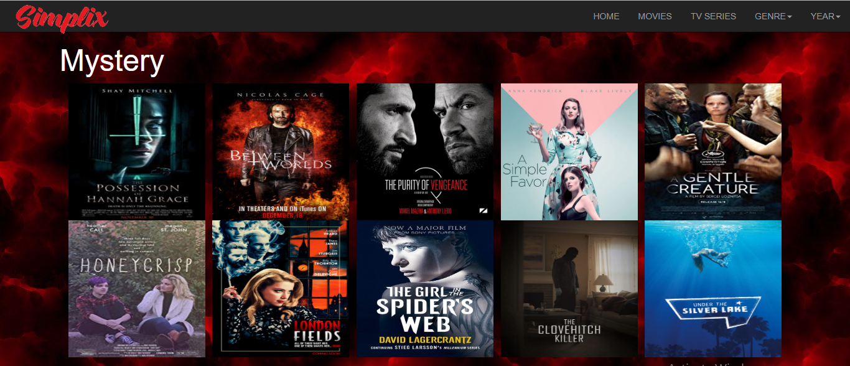

**SHORT**

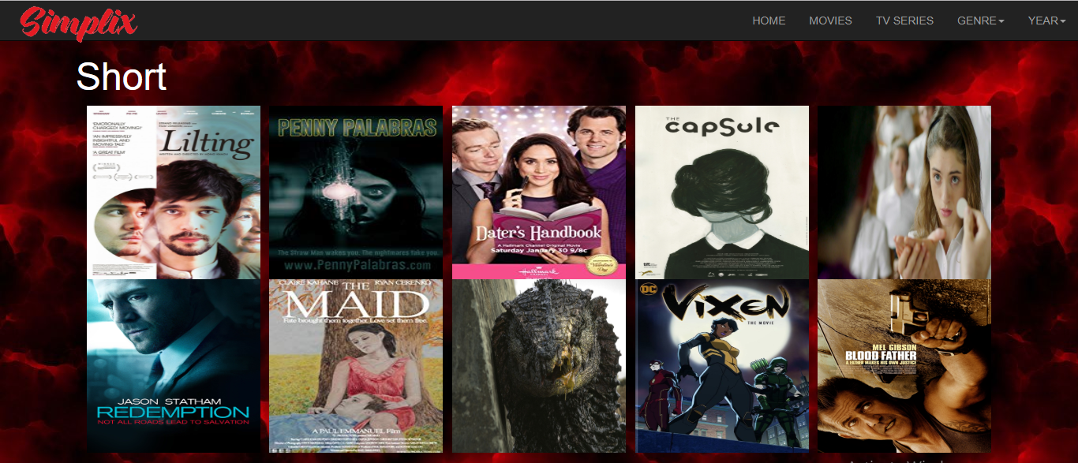

**PSYCHOLOGICAL**

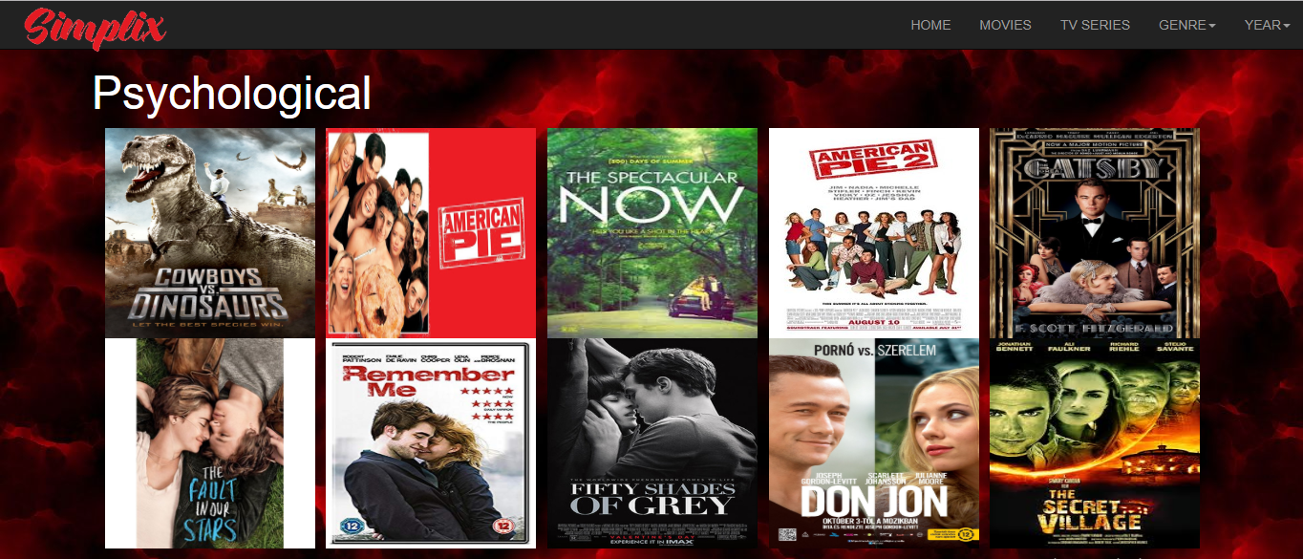

**ROMANTIC**

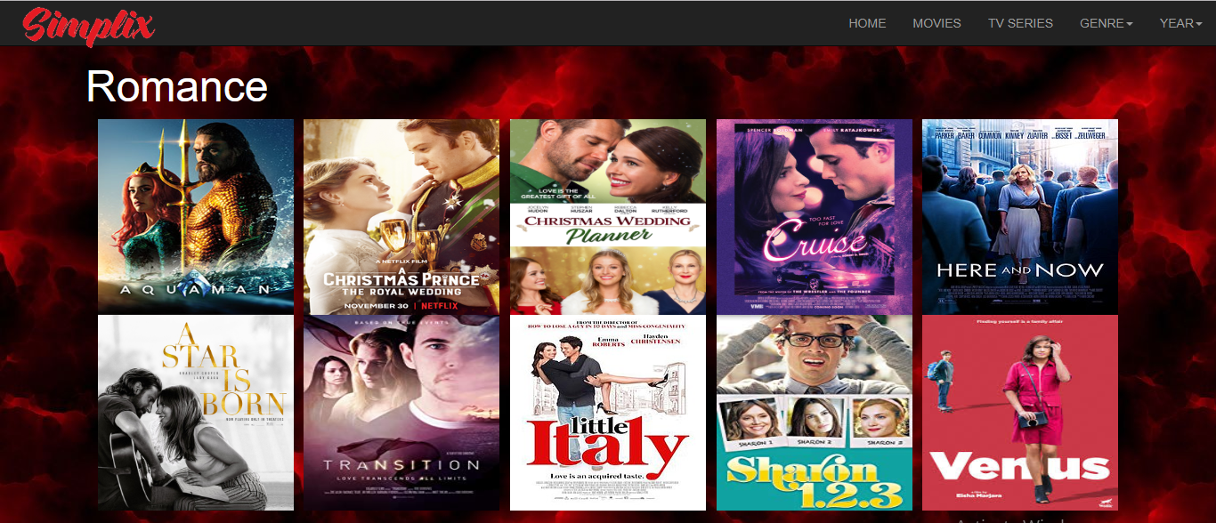

**YEARS**

**2015 MOVIES**

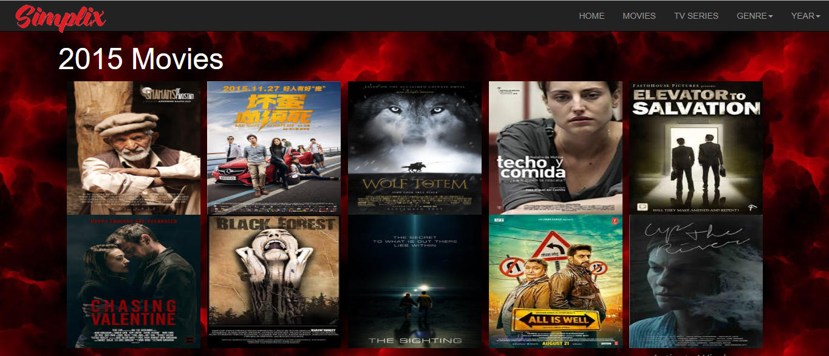

**2016 MOVIES**

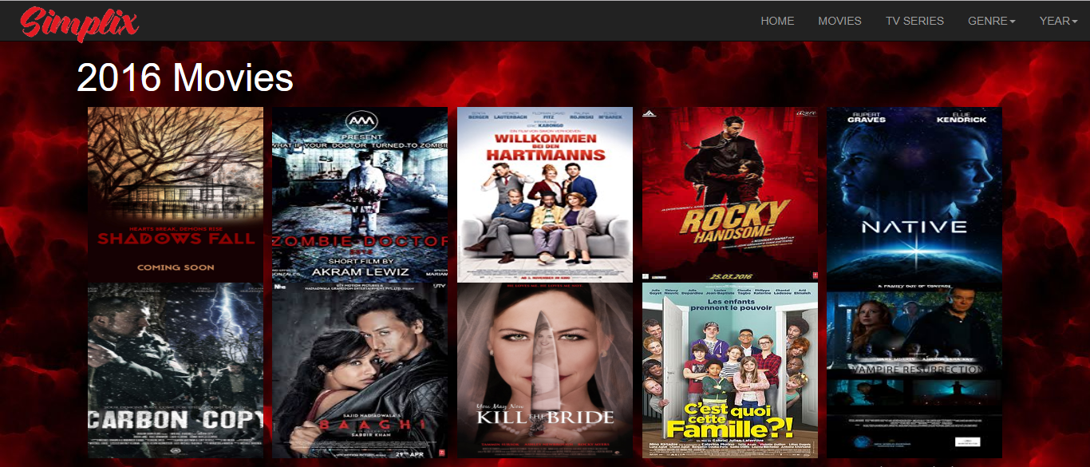

**2017 MOVIES**

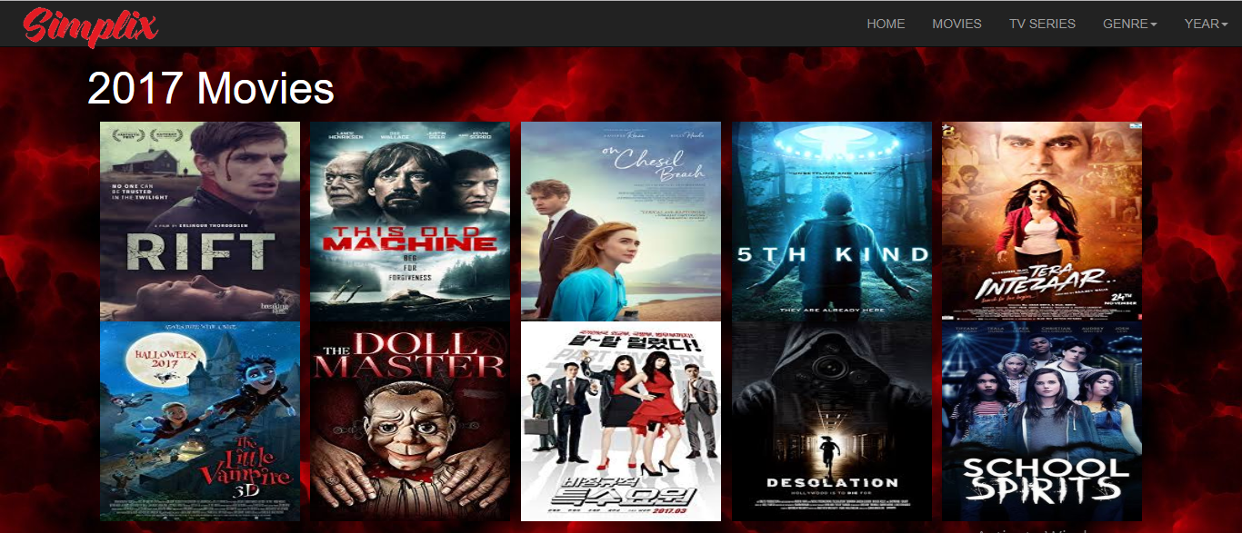

**2018 MOVIES**

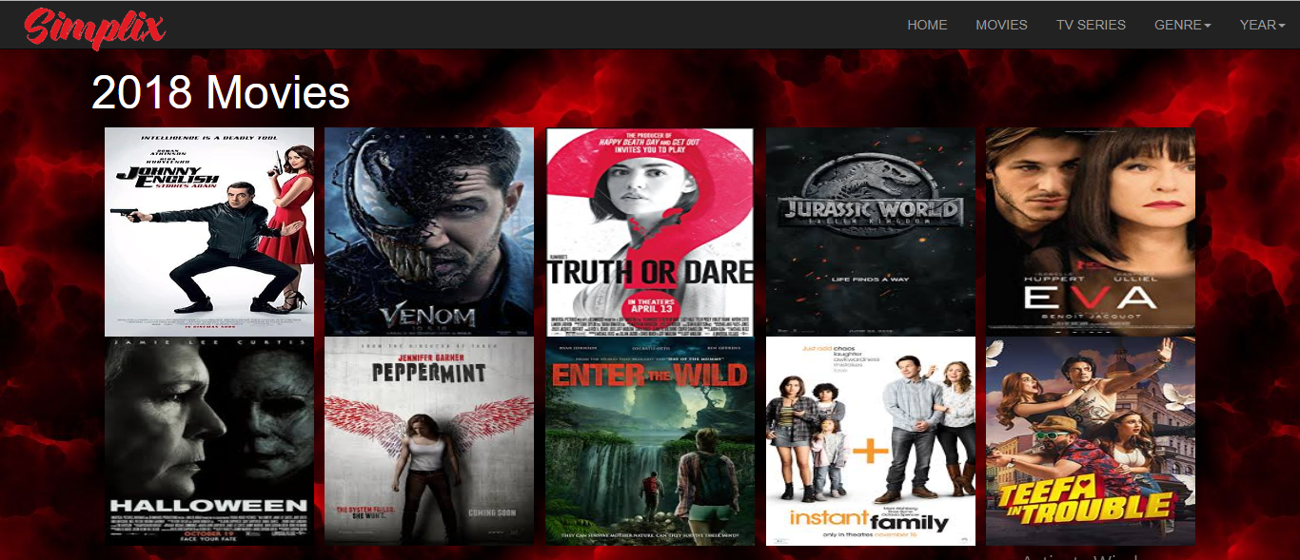

**CONCLUSION**

Simplix website is a great platform for streaming online contents and it is a user friendly too. It provides online free movies to the users’ .Since Simplix offers a massive selection of movies available for free and without registration therefore it only host the content of 123movies.to watch online free movies on Simplix, just search simplix on your any web browser go to its home page and watch any of your desired movies for free.

**REFERENCES**

1. <https://www2.movies123.io/?fbclid=IwAR2-zwkwsC1L5T3QnRVXHQvRY9vyhGc7xsLVRLQsjHAoNBmBNzBqrDxFkFc>
2. <https://123movies.la>